**CSC 417 Unit 2 Day 7 Outline**

1. Generative Adversarial Networks

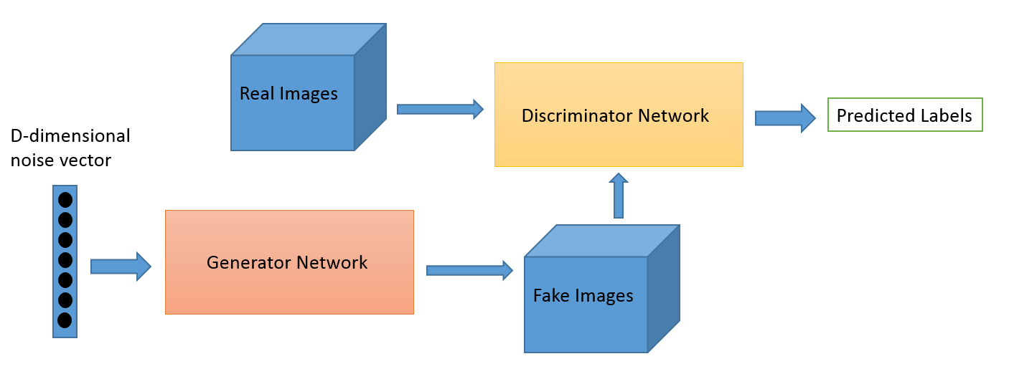

* 1. Pit two neural networks against each other to generate new *synthetic* data that passes for actual data
     1. Example: generating a new face that is not a copy of any specific person but appears to be an actual human face
  2. Combine generative and discriminative algorithms in one system
     1. Discriminative algorithms
        1. Classify input data
        2. Predict category to which data belongs
        3. Learn decision boundary separating categories
        4. p(y|x)
           1. Probability that item is in a particular category given its features
     2. Generative algorithms
        1. Predict the features that are characteristic of a given category
        2. Model distribution of categories in the data
        3. p(x|y)
           1. Probability of a feature existing in a given category
  3. GAN Process
     1. Random noise is fed into a generative network
     2. Generative network produces a “fake” (synthetic) data item
        1. Initial attempts are *very* random –   
           images often begin as unrecognizable   
           “static “
     3. “Fake” (synthetic) images are fed into a discriminator network along with “real” images from the given category
     4. Discriminator returns probability that each image is fake or real
     5. Example: synthetic handwriting
        1. Discriminator may be a CNN
           1. “Downsamples” image to probability it is real or synthetic
        2. Generator may be an “inverse” CNN
           1. “Upsample” random noise into an image
           2. Generates new examples of a given class
  4. GAN Training
     1. Extensive training time is required
     2. Many epochs may be required to obtain a “realistic” synthetic data item
  5. Mode Collapse
     1. Generator over-optimizes for a particular discriminator
        1. Learns one *specific* output that fools the discriminator